

Name: M.Eswarcharan Course Code: ITA0330
Reg No: 192372739 CourseName:Mobile Computing

3.Experiment: Network Switching Subsystem Flowchart Using Figma

Aim: To develop a flowchart in Figma illustrating the operation of the Network Switching Subsystem (NSS) in a mobile cellular system.

Procedure:

- Open Figma and create a new design file.
- Use oval shapes for Start and End.
- Use rectangles for processing steps and diamonds for decisions.
- Connect all shapes using arrows.
- Add Yes and No labels to the decision branches.
- Apply suitable colors and align the shapes neatly.
- Test the flowchart and save the design.

Output:

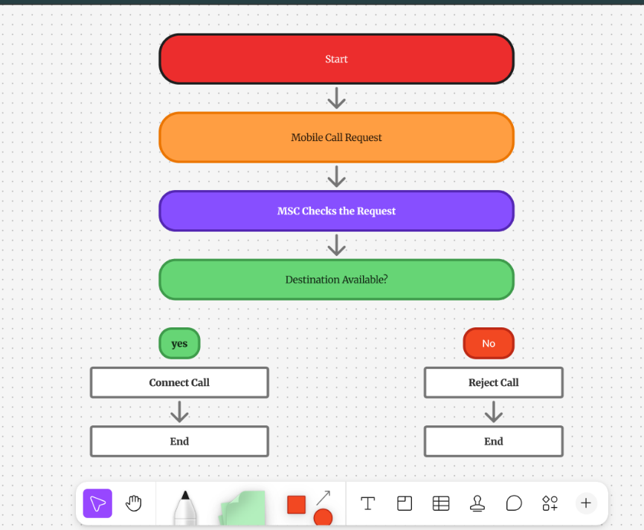

Result: A flowchart illustrating the operation of the Network Switching Subsystem in a mobile cellular system was created.

